Project Design Phase-II
Data Flow Diagram & User Stories

Date31 January 2025Team IDSWTID1741243627158259Project NameRhythmic TunesMaximum Marks4 MarksTeam Details:
Team Leader: SHREE.V – vshreecs22.krmmc@gmail.com
Team member:DHANUSHREE.S – sdhanushreecs22.krmmc@gmail.com
Team member:KEERTHIGA.R – rkeerthigacs22.krmmc@gmail.com
Team member:PRITHIKANISHA.G – prithikanisha2003@gmail.com
Team member:LAKSHMINARASIMHAN.P.M – pmlakshminarasimhancs22.krmmc@gmail.com
Data Flow Diagrams:
A Data Flow Diagram (DFD) is a traditional visual representation of the information flows within a system. A neat and clear DFD can depict the right amount of the system requirement graphically. It shows how data enters and leaves the system, what changes the information, and where data is stored.

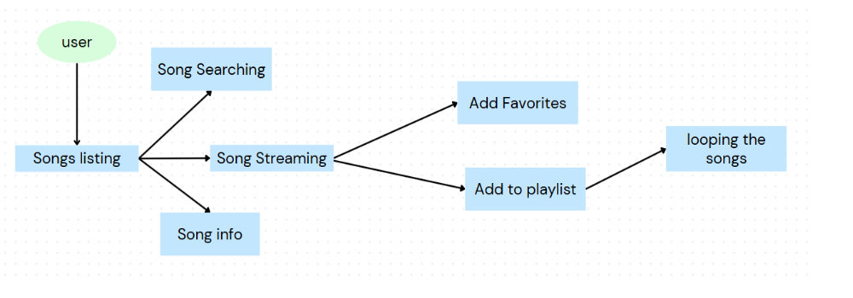

User Stories

User Story Table – Music Streaming App
User TypeFunctional Requirement (Epic)User Story NumberUser Story / TaskAcceptance CriteriaPriorityReleaseMusic DiscoveryUSN-1As a user, I can search for songs, albums, or artists.I can see a list of relevant search results.HighSprint-1USN-2As a user, I can view trending and recommended songs.I can see recommended music on my dashboard.MediumSprint-2PlaybackUSN-3As a user, I can play, pause, and skip songs.I can control playback with basic buttons.HighSprint-1USN-4As a user, I can view album artwork and song details while playing a song.I can see album art, song title, and artist name.MediumSprint-2Playlists & FavoritesUSN-5As a user, I can create my own playlists.I can save a collection of songs under a custom playlist name.HighSprint-2USN-6As a user, I can add or remove songs from my playlists.I can successfully manage songs within a playlist.HighSprint-2USN-7As a user, I can like/favorite songs.I can save my favorite songs and access them later.MediumSprint-2Audio StreamingUSN-8As a user, I can stream high-quality audio.I can listen to songs without buffering.HighSprint-1

